|  |  |  |
| --- | --- | --- |
| Assignment 1 | | |
| DataFrames and Matrices | | |
| Student Name: saja | Section No: | Student ID : |

Create a dataframe using pandas DataFrame

1. Using NumPy and pandas create a data frame called “dataset” that contains the following columns:
   1. ‘X’ which contains numbers between 0 to 49
   2. ‘sin(x)’ contains the values of sine x values that generated in 1.
   3. ‘cosin(x)’ contains the values of cosine x values that generated in 1.
   4. ‘tan(x)’ contains the values of tan x values that generated in 1.

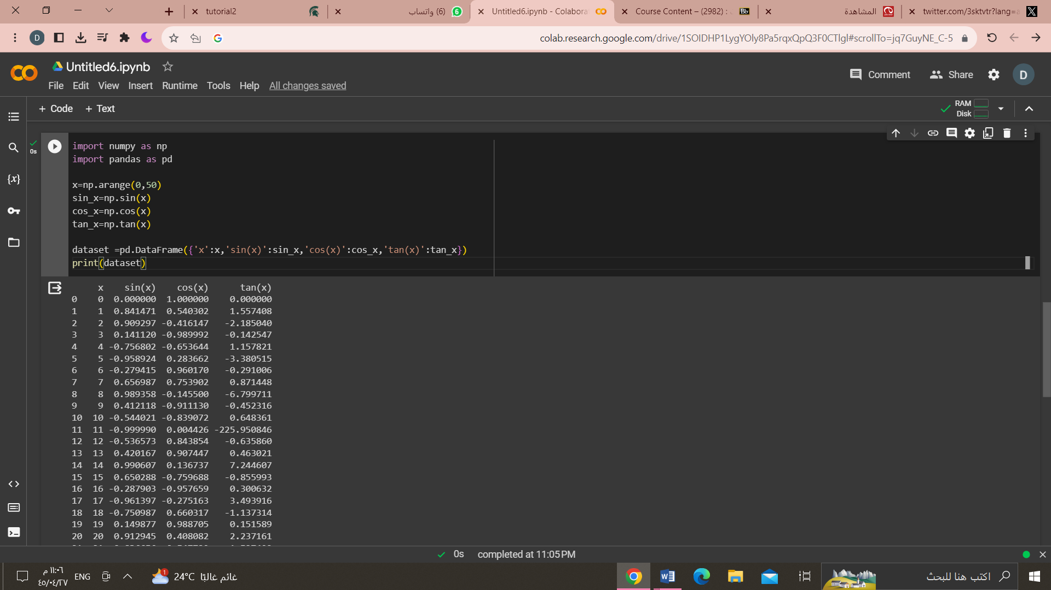

1. Show the head of the dataset after composition.

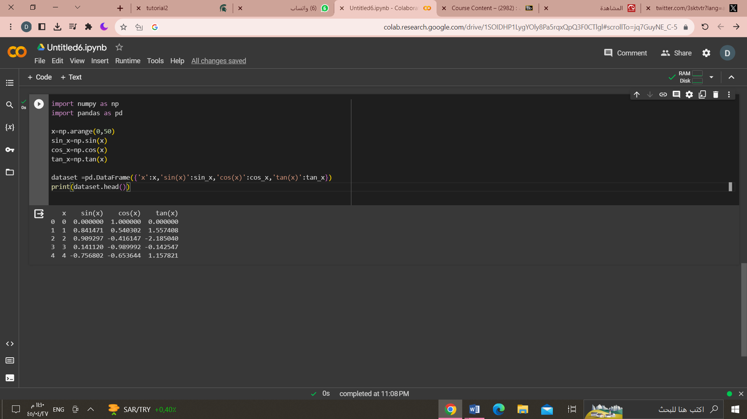

1. plot the x, sine(x), cosine(x), and tan(x).

